Figure.

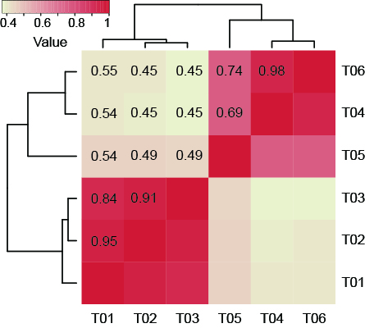
Figure. S1 Heatmap of the correlations among samples

Figure S2 Quantification of transcripts levels were measured by real-time qRT-PCR analysis and normalized relative to anthocyanins synthesis.

